General navigation framework

Initial asumptions
- Perfect comunications
- Perfect localisation
- Gloabal planner -> We can use ROS nav stack for Astar like planners
- Leader stays the same during all the experiment
- All agents are either within the fleet or outside the road
- A sphere of influence around each agent is going to be defined to relax the communication load

Structure of the platform → Best option found is this: “Train here, drive there: ROS based end-to-end autonomous-driving pipeline validation in CARLA simulator using the NHTSA typology”

Expected behaviour of the algorithm

- We have a leader collecting all the global plans asynchronously (whenver something changes)
- During navigation we need to check for situations that could lead to one of this cases

- Some kind of deadlock
- Scenarios where a particular agent is excessively penalised
- Online reconfiguration

- This algorithm should deliver modified plans that overrule the individual plan of certain agents so that those situations are avoided.

- Special cases that might be considered in the future
  - Interaction between two squads that work induvialy
  - Ad-Hoc growing of the platoon in scenarios like an intersection

- Some examples in this line of work:
  - There was some work done using petri nets to control the general behaviour of the system → Like hard coding different states

- Some ideas
  - Most of this cases can be detected as “crossings/overlapings” between global plans (for example one vehicle wants to turn )
  - If detected, we need to do two things
    - Stablish a priority order minimising some cost -> Need to be defined, probably something similar to the path selection problems or an scheduler
    - Temporally rearange the squad formation so that the maneoveures can be executed according to the priority order. -> Probably is sorted out through the priority, we can force the behaviour through the MPC constraints

State of the low level MPC research.

Currently we have two possible formulations:

- Frenet frame based - > States are formulated using the errors Ey and Eth

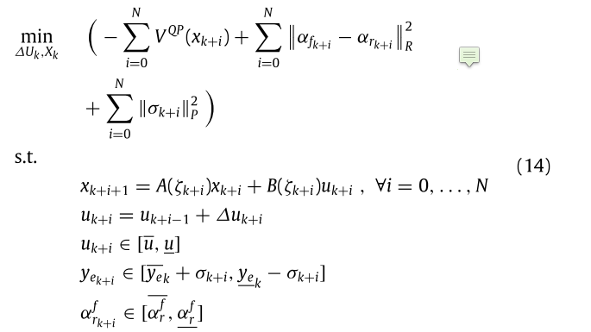

3 modifications that could be added to the system for the multi robot implementation

- Modify the cost function
  - Redising to avoid the aproximated term of the velocity →
  - Relax the track error bounds (we may allow certain collisions along the horizon to relax the optimisation problem if that leads to improved resutls)
  - We can use the derivative of s in our model similar to “Motion Planning and Control for Multi Vehicle Autonomous Racing at High Speeds” -> How does that make sense?
- Add the colaborative constraint
  - Each agent computes a tube of ey non admitited along the horizon N and forwards it
  - Apply
    - For j = 1:Horizon comptue s -> ideally we would want this as a system state
    - Ey_j = f(s) -> we should generate regions for each value of s and concatenate the constrains as ANDs
    - ISSUE -> we need to activate the constraint only around a given value of s

Notes
Referencing wrt the curvature should be easier but not sure if we have to add s as a variable
We need to adapt the system from Cartesian to Frenet → We can apply this transformation “An Efficient Generation Method based on Dynamic Curvature of the Reference Curve for Robust Trajectory Planning”
When dealing with two lanes we need the reference to be centered in the current line, and when sharing information we need to be very careful wrt which curve are we using
Not so straight forward to map the constraints into the optimisation problem

- Cartesian based frame - > States are formulated using x and y

example formulation: AMZ Driverless: The Full Autonomous Racing System -> They did an extended version with Fernet frames as the one seen before “Motion Planning and Control for Multi VehicleAutonomous Racing at High Speeds“

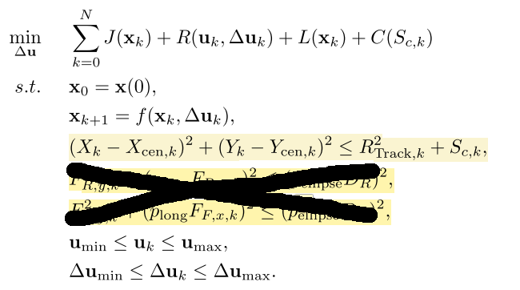

3 modifications that could be added to the system for the multi robot implementation

- Modify the cost function → it general it can be adapted to the autonomous driving
  - Redising to avoid the aproximated term of the velocity → as the velocity might be quite constant we may be able to express it in other terms
Relax the track error bounds (we may allow certain collisions along the horizon to relax the optimisation problem if that leads to improved resutls)

- Colaborative constraints
  - Right now the system generates an elipsoid around the track to control if the reference point to assess whether or not we are actually following the track, an alternative formulation cited is done using a linear aproximation.
  - We may struggle mapping world coordinate “boxes” into the constraint space, some examples can be found in this paper and in: Cooperative driving using a hierarchy of mixed-integer programming and tracking control

NOTES
It is easier to interface it with other algorithms
You don’t need to switch lane centers and all agents are referenced wrt the global f rame
It may be computationally expensive to generate the free space constraints
We need to add constraints so that the system remains within the actual road limits
Some examples of how to represent the free space can be found in the paper mentioned before

